Grading Procedures

- Access your grading list by clicking on ‘Grading’ from the Faculty menu on myNIC.
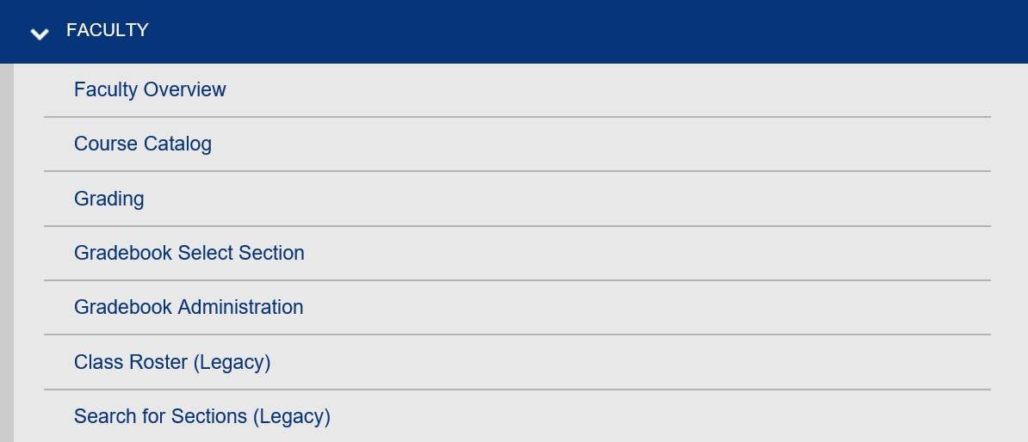

- Enter the Term of the course to grade or enter start and end dates for any courses whose end dates fall after the regular college term dates. For example, if instructing a continuous/entry exit section, enter the start and end date of the course, e.g., Sept 1/20 to June 8/21. College terms are:
  - Fall – Sept 1 to Dec 31
  - Winter – Jan 1 to April 30
  - Spring – May 1 to June 30 (7-week term)
  - Spring – May 1 to Aug 31 (14-week term)
  - Summer – July 1 to August 31

SRO/October/2020

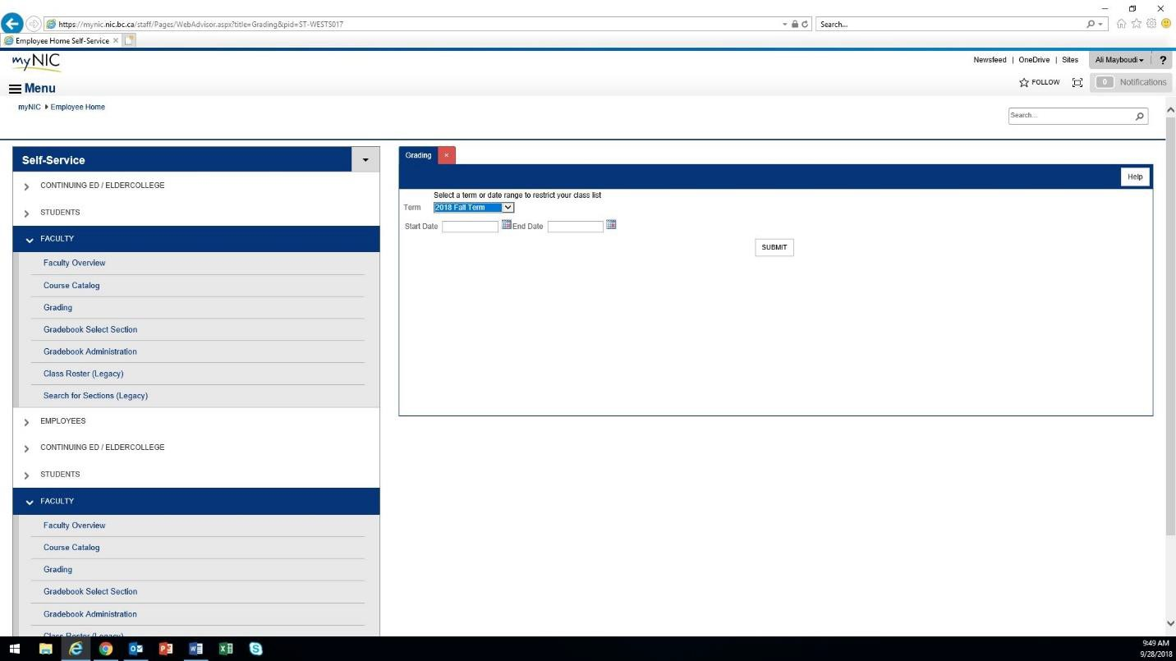

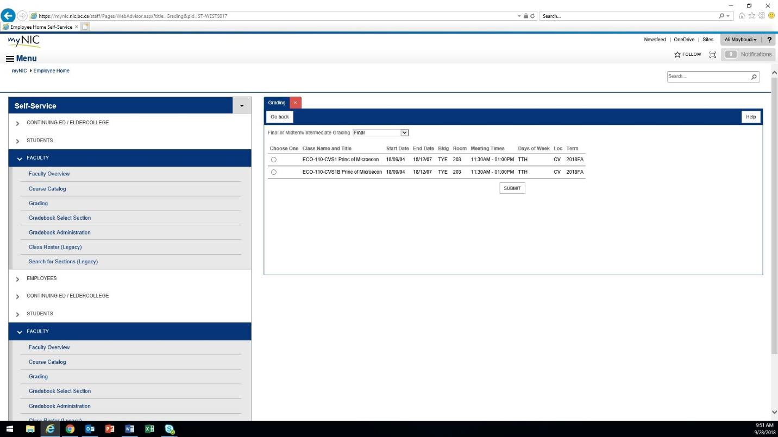
- Select the course to grade out.

- Select Final from the drop-down menu. Never select interim grades.

- Grade the students based the grade scheme of the course.

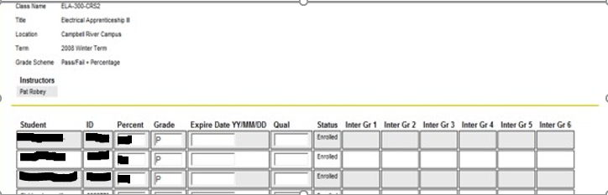

  - For a Pass/Fail grade scheme enter only a P or F in the grade column. Do not enter percentages.

  - For a Letter Grade grade scheme, enter only the letter grade. Do not enter percentages as this will generate an error. Only enter letter grades as they correspond to the grade scheme on your course (LGS1 or LGS2) per policy 4-14 Grade System

  - If you are using an INC (Incomplete) grade, enter the expiry date using year/month/date format in expiry date column.

  - The Qual field is only used for OAD courses. For OAD enter the Words per minute. e.g., W45

  - The interim columns are left blank.

  - Click submit once all grades have been entered.

- A confirmation screen will appear. Select OK to return to the main menu and repeat these steps to enter the next course. Grades will verify overnight to the student’s record. Grades may be revised in the same day that the grade was entered, afterwards a Grade Change Request Form is required to revise the grade. Grade Change Request forms can be emailed to studentrecords@nic.bc.ca.

