NOTE: Before you can use Self-Service Password Reset you will have to confirm your authentication methods. The first/next time you login to NIC MS365, you will be guided to setup your SSPR options with a “More information required” followed by the setup procedure and options.

- Go to http://www.office.com & select Sign in.

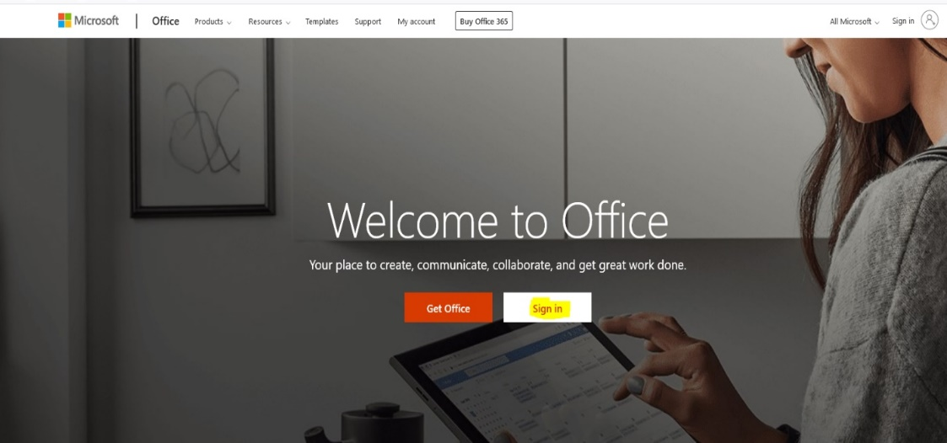

- Enter your NIC email address & select Next. E.g., firstname.lastname@nic.bc.ca

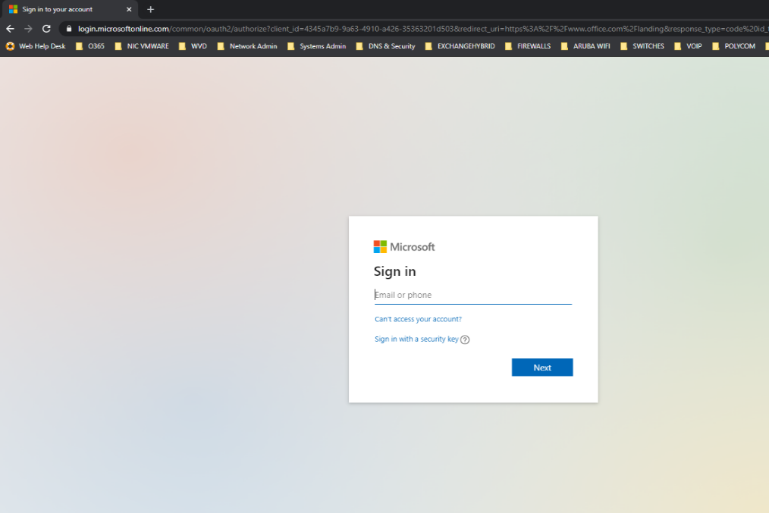

- You will be re-directed to our NIC MS365 Logon Portal where you will enter your NIC Password.

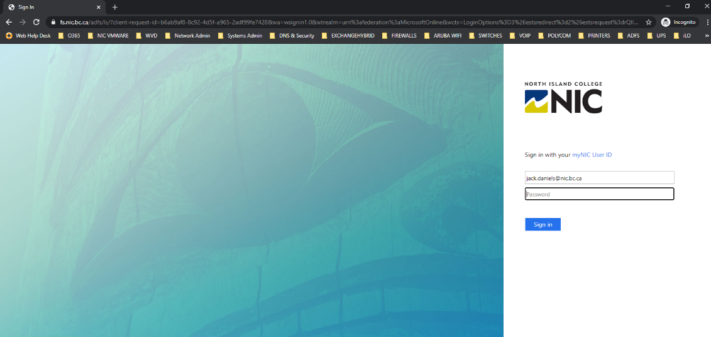

- You will then be presented with the “More information required” dialog. Click Next and
you will be guided through the SSPR setup procedure and options.

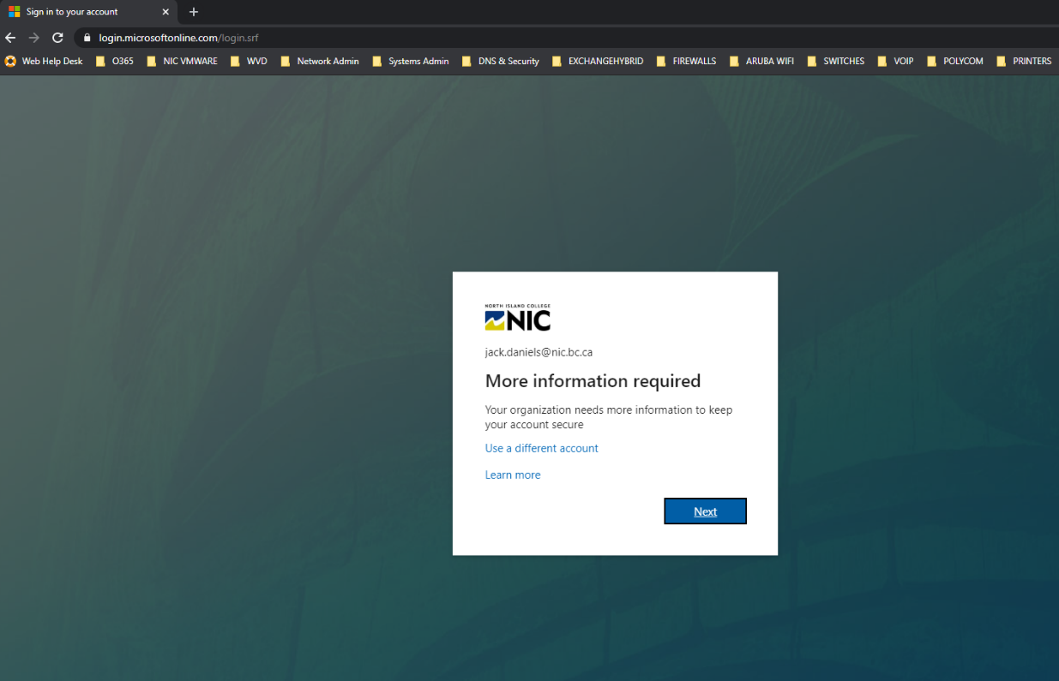

- Once redirected to the setup options you will be required to setup up at least 1 of the 4 options available. It is recommended at a minimum to use the Authentication Email & Security Questions.

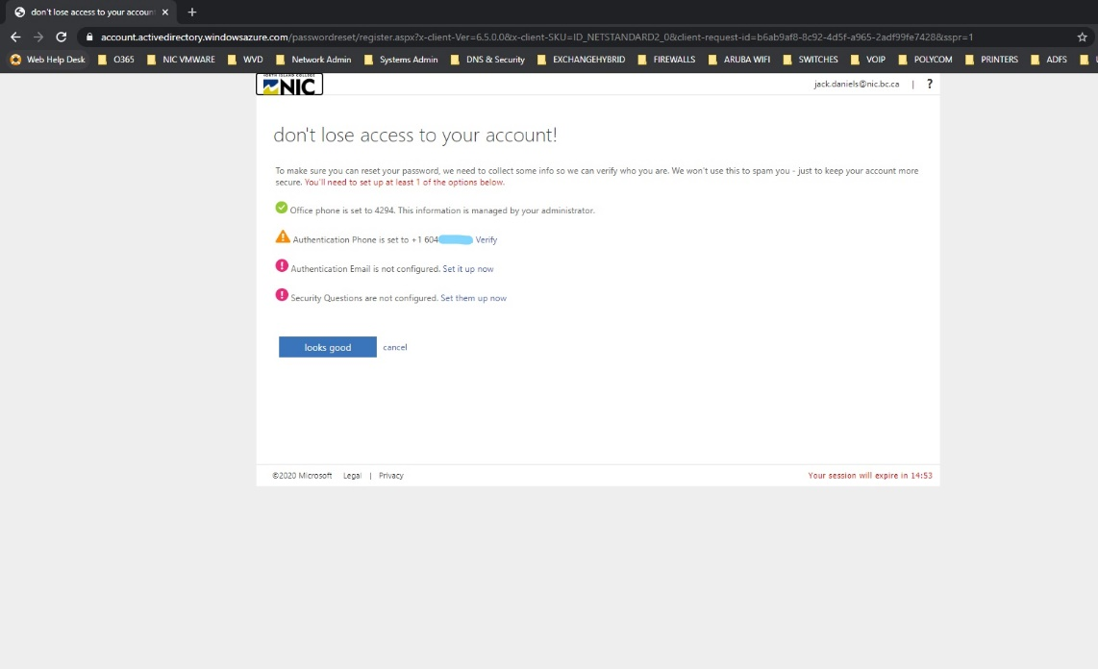

- Once completed you will be redirected to the MS365 regular logon. You now have the ability
to reset your Password & Unlock your account when necessary.

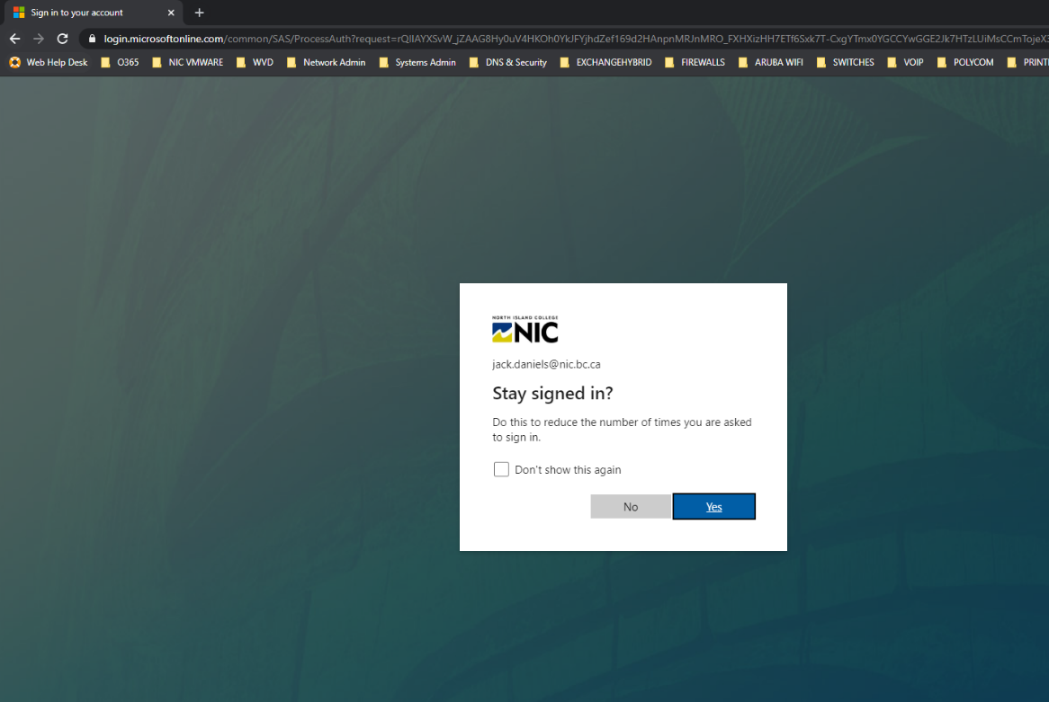

- To reset your Password or Unlock your account make note of the following URL:

https://aka.ms/sspr
This site will walk you through the reset/unlock process.
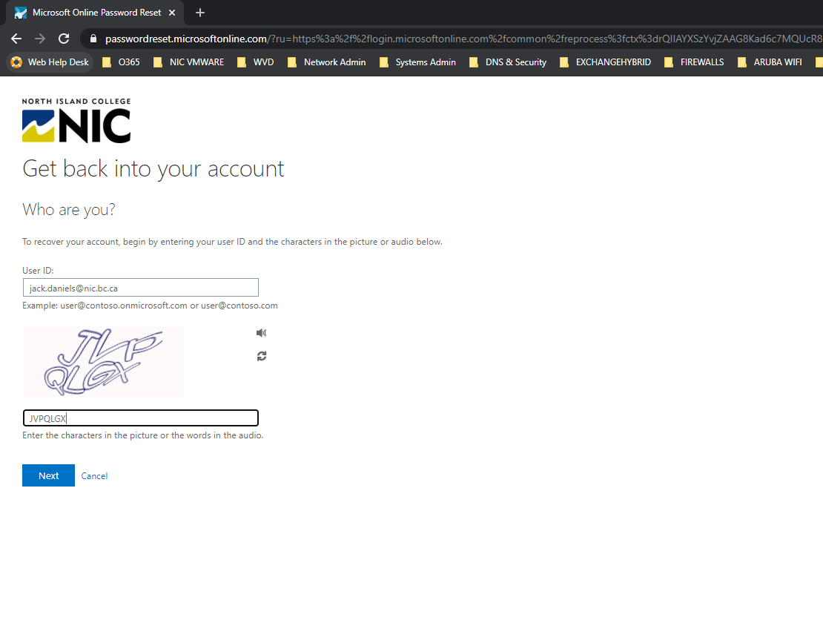
Enter you NIC email Address E.g. firstname.lastname@nic.bc.ca and hit Next.

- Select the option that best suits your situation. Option #1 will help reset your Password & Option #2 will help Unlock your account. Here is Option #2 walk-through.
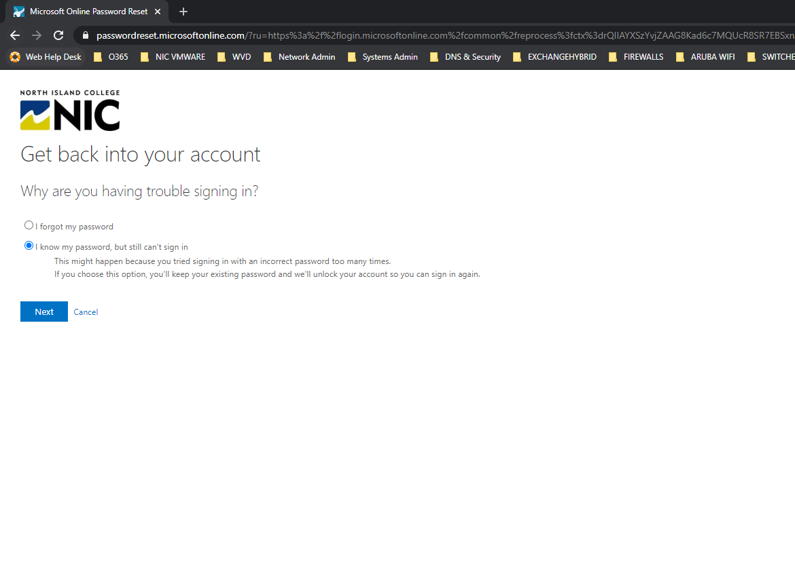
- Select your desired recovery option from Step #5 and walk through the process.

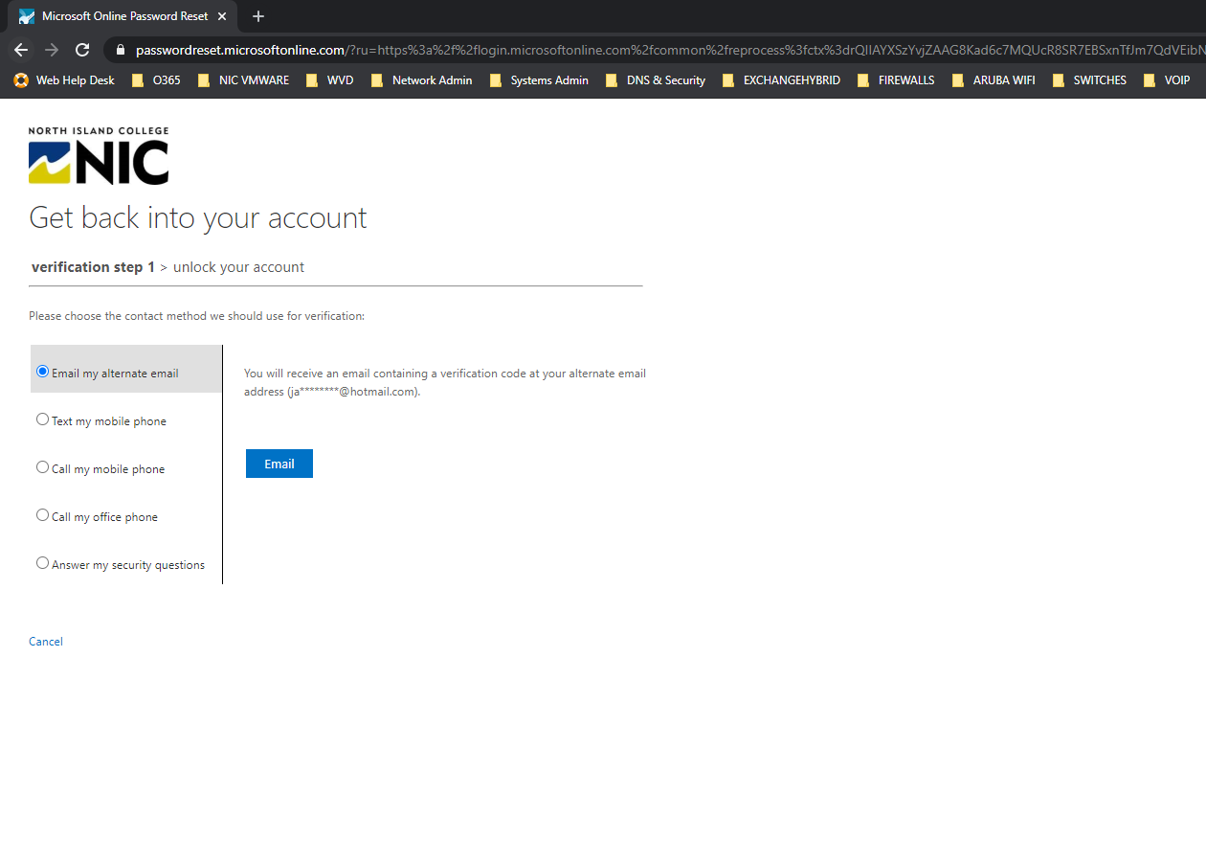

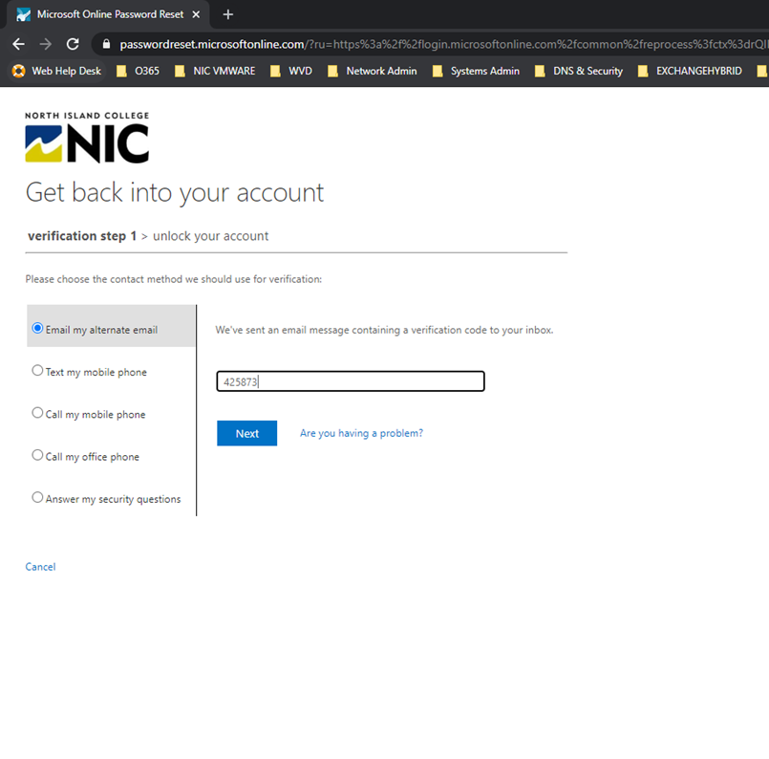
- A verification code will be sent to your email & mobile by text or call. Alternatively, you can answer your Security Questions if you completed this option.

- You have now successfully Unlocked your NIC user account.

Please note - If you find that your account becomes locked repeatedly, after unlocking it, please call the helpdesk for assistance.

